- Please use this only as inspiration. Our final design must be original.
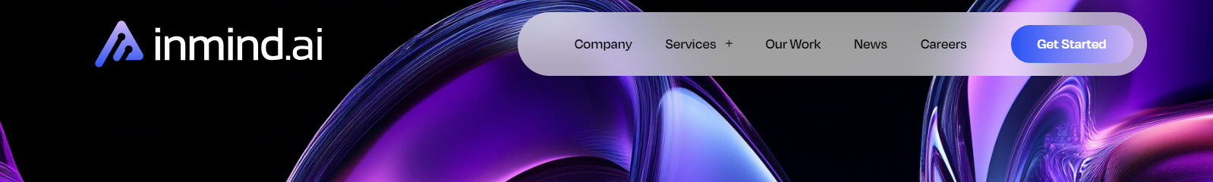

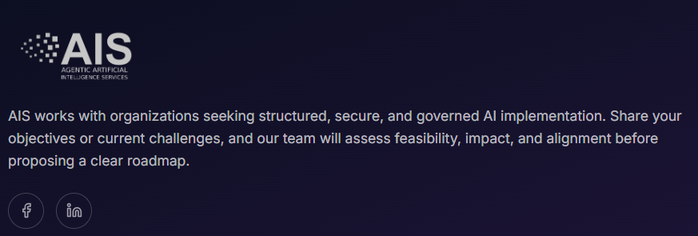


Remove it


Connect with AIS or Speak with

Our Experts
- 
Increase the font size
Increase the font size

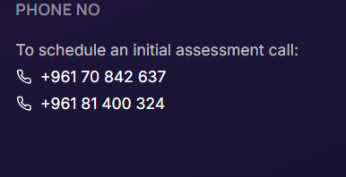

Add UAE contact number

Copyright© 2025–2026 AIS. All Rights Reserved. Privacy Policy | Terms of Use | Responsible AI | AI Ethics

Our approach is grounded in human oversight, responsible governance, and structured delivery. We believe AI should augment people, not replace them — enabling teams to lead with better intelligence, clearer decisions, and more efficient operations. Our systems are designed with transparency, accountability, and human-in-the-loop controls to ensure AI remains explainable, secure, and aligned with organizational policies and regulatory expectations.

Add engineering in both

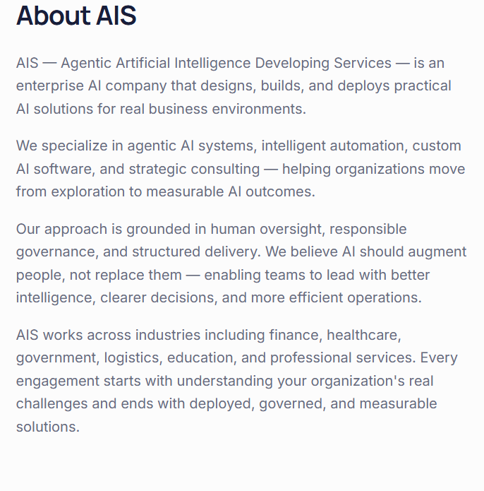

Our Identity & Logo Meaning
The AIS identity is built on modular squares — each block represents a system, a decision unit, a workflow, or a sector. These blocks connect to form structured agentic ecosystems.
Humans supervise and guide. AI executes within boundaries. AIS connects these blocks into cohesive, governed systems that deliver real outcomes.
Our visual language reflects this philosophy: clean geometry, structured layouts, and purposeful connections — never chaotic, always intentional.

Our Identity & Logo Meaning
The AIS identity is built on modular squares — each block represents a system, a decision unit, a workflow, or a sector. These blocks connect to form structured agentic ecosystems.
Humans supervise and guide. AI executes within boundaries. AIS connects these blocks into cohesive, governed systems that deliver real outcomes.
Our visual language reflects this philosophy: clean geometry, structured layouts, and purposeful connections — never chaotic, always intentional. This structure represents how AIS builds AI systems that are reliable, transparent, and designed to operate with clear oversight and accountability.
AIS is built on the belief that powerful AI must be structured, governed, and always guided by human judgment.

Kindly go through all the text on the website and remove the hyphen symbols (-) that appear in the middle of sentences. Some of them were automatically generated during drafting, and we would like the paragraphs to appear clean and natural.

Sometimes contact us is showing
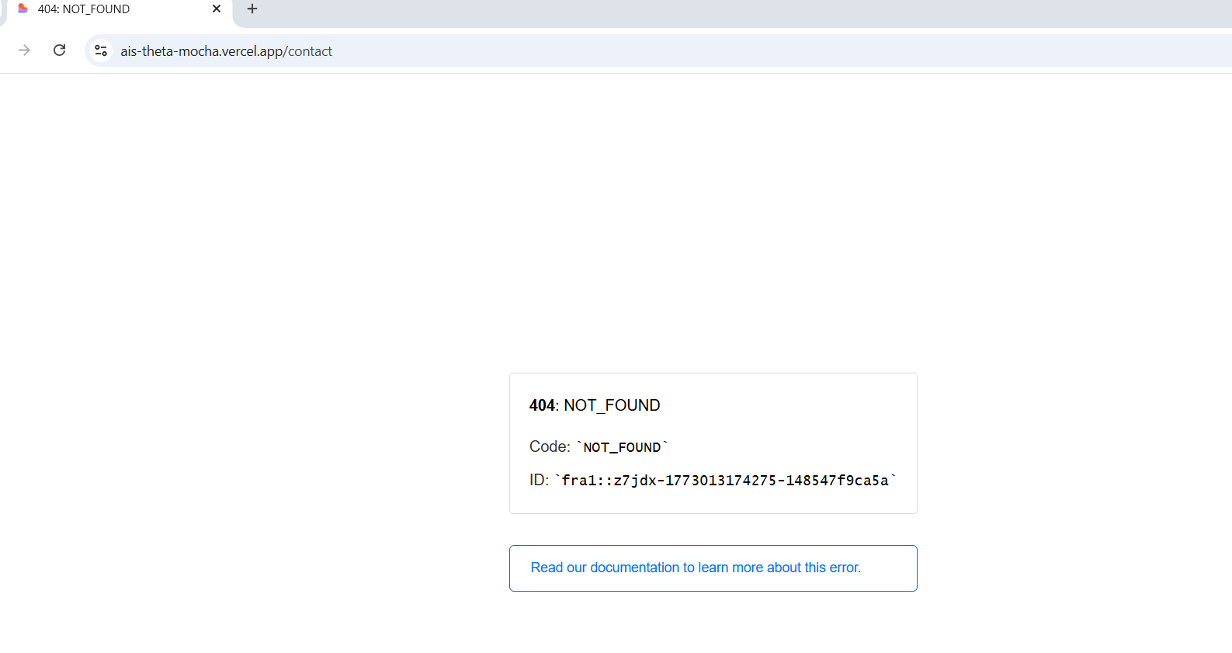

- Add join us 